**Zoom Meeting Connector**

Description

This module is for integration of zoom meeting to mendix application using server to server authentication.

Usage scenario

When there is need to integrate zoom meeting and managing zoom meeting from mendix application.

Features

* Create Meeting.
* Update Meeting.
* Delete Meeting.
* Join Meeting.

Limitations

* User cannot add invitees in the meeting.
* User can only set attributes meeting name, time, agenda, duration.

Screenshots

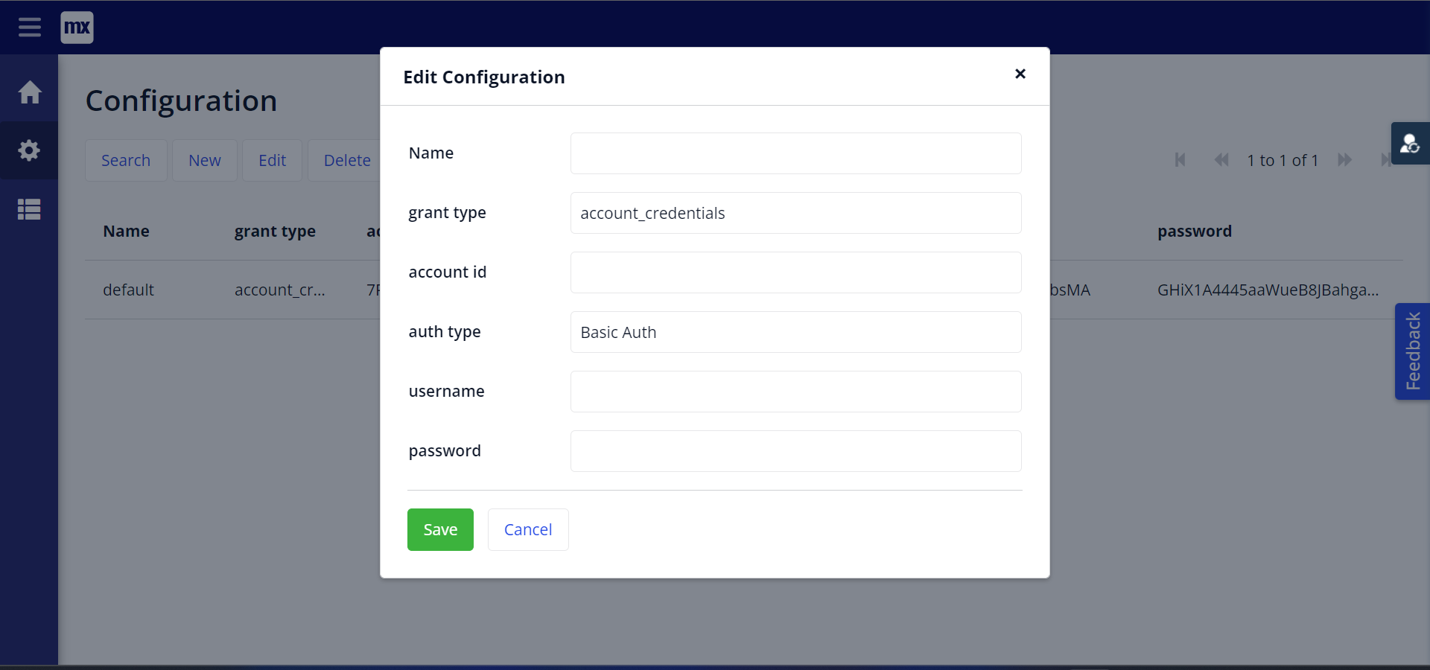

Dependencies

* Mendix Studio Pro 9.12.4 or higher.

Installation

1. Download and install all prerequisite modules in your application.
2. Add **meeting_overview** and **configuration_overview**  page at navigagtion.
3. Run the application.
4. Create a zoom **server to server OAuth** application from [here](https://marketplace.zoom.us/develop/create).
5. Now inside mendix app go to configuration_overview page click New button fill name as **default** enter all details you will get them from zoom app and save.
6. Go to meeting overview page there you can see all the meetings list and create meetings.

**Configuration: NA**

**Category: Module**

**Subcategory: All**

**Visibility: Public Marketplace**

**Studio Pro Version: 9.12.4**